

A few weeks ago, I shared a graphic – the Emotional Pyramid of Needs – with an invitation to identify any emotional needs that were perhaps being neglected in these complex times. I got such strong feedback about how helpful the model is right now, that I want to take a deep dive into it with you.
Right now we are facing one of the biggest challenges in our lives: a global pandemic which is forcing us to stay within our homes or distance ourselves from our family, friends, and neighbors. It’s a time full of uncertainty, anxiety, and sadness, and it’s easy to get overwhelmed with these tough emotions.
On the one hand, we might obsessively brood on our feelings, struggling to sleep in the face of discouraging statistics or overthinking a minor quarrel with a spouse. On the other, we might bottle our emotions, blindly pursuing a sense of normalcy that right now doesn’t truly exist, or rationalizing our way out of them (“I shouldn’t be sad.”). Our culture often dictates the idea that natural emotions are either good or bad, positive or negative, and we can find ourselves forcing happiness rather than observing how we are actually feeling. Now, don’t get me wrong. I’m not anti-happiness. I like being happy. I’m a pretty happy person. But when we push aside normal emotions to embrace false positivity, we lose our capacity to develop skills to deal with the world as it is, not as we wish it to be. Now is not the time for white-knuckled control. Instead, it’s the time to cultivate the wisdom and courage to move forward with emotional agility.
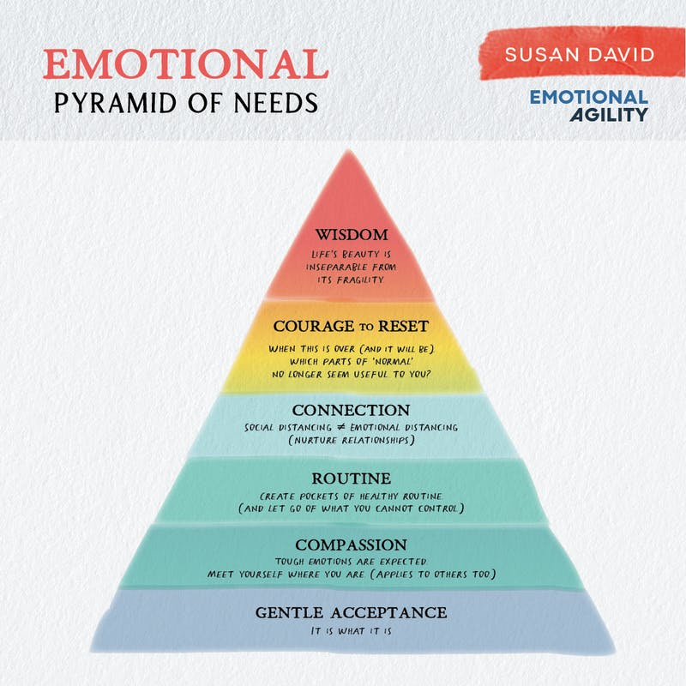
The pyramid model I’ve developed (above) illustrates the critical steps we can follow to deal with both the reality of our present and the emotions that come with this reality, in a healthy way. The steps outlined can leave us more resilient and stronger than ever.
- Gentle Acceptance: As much as we want to, we cannot control every situation–especially a global pandemic. There is no value in struggling to deny or suppress feelings of anxiety, hopelessness or grief. This only makes us feel worse. By showing up to a difficult situation and accepting it, we are freed up to move beyond it. Acceptance is the prerequisite for positive change.
- Compassion: You must be kind to yourself. These are not normal times: tens of thousands of people are dying and losing their livelihoods. Recognize with kindness that you are trying to live your life and juggle competing demands in abnormal circumstances. Give yourself a break and let go of perfectionism. Now is not the time for perfection but for forgiveness and flexibility. Also, see if you can let go of judging others. They, too, are doing the best they can. You don’t have insight into the history of the woman who is hoarding food or what it is she has seen in her past, but she is scared. Try to broaden your scope.
- Routine: Human beings need routine in order to maintain a sense of order. It’s the glue that holds us together from day to day. When we are faced with the unfamiliar, we tend to fill in the gaps with fear. We are currently away from our routines–working from home, homeschooling, and living in close quarters with others. We are adapting to unprecedented circumstances. This can be scary. So let’s fill in the gaps of the unknown with things that are comfortable, familiar, and connected with our values. Healthy routines are essential, specifically those associated with sleep, exercise and eating. Our bodies and minds are so interconnected and our physical health is reflected in our psychological state. Try to ground yourself during the course of the day by incorporating experiences that are reminiscent of your normal lifestyle. Whether that means waking up at the time you normally would to commute to work or maintaining your family tradition of Friday movie night, the preservation of these small habits will give you comfort. Remember that it may not be possible to adhere to all aspects of your regular routine and approach this new reality with grace instead of rigidity.
- Connection: It’s important to note that “social distancing” is really physical distancing. Connection is so important, now more than ever. Even though you cannot be in someone’s physical presence, you can continue to nourish your relationships, especially if you’re feeling lonely. You need that support. Also, if safe, make sure to hug your child and/or partner. Put down your phone and laugh with your family, play games, do puzzles.
- Courage: Research now shows that the radical acceptance of all of our emotions–even the messy, difficult ones–is the cornerstone to resilience, thriving, and true, authentic happiness. But courage is more than just the acceptance of emotions. Our emotions are data that tells us what we’re missing in our lives. A ‘guilty’ parent might be missing real connection with her child. Grief is love, looking for its home – reminding us of the our special times. Slow down and face into your difficult emotions with courage. What you find there will signpost to you how to make better decisions and take values-based actions.
- Reset: This is the time for reflection. What priorities did you once have that no longer seem important? What parts of ‘normal’ do you not want to rush back to? Gather your data, keep a journal, and reflect on what you learn about yourself. This information is valuable and it will guide you as you move forward.
- Wisdom: Life’s beauty is inseparable from its fragility. We are young until we are not. We walk down the streets sexy until one day we realize that we are unseen. We are healthy until a diagnosis brings us to our knees. The only certainty is uncertainty, and once we realize this as truth, the healthier and more authentically happier we will be. When I was little, I would wake up at night terrified by the idea of death. My father would comfort me with soft pats and kisses. But he would never lie. “We all die, Susie,” he would say. “It’s normal to be scared.” He didn’t try to invent a falsely positive buffer between me and reality. It took me a while to understand the power of how he guided me through those nights. What he showed me is that courage is not an absence of fear; courage is fear walking.
Our time on this earth is all too short and all too precious. Life is asking us all right now–are you agile? Let the answer be an unreserved “yes.” It’s a yes borne of a correspondence with your own heart–in seeing yourself for who you truly are. Because in seeing yourself, you are also able to see others, too: the only sustainable way forward in a fragile, beautiful world.
Wishing you well,
Susan
This essay was featured in the April 19th edition of The Sunday Paper.

