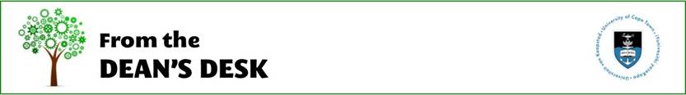
Dear colleagues
As we reach the end of day 50 of lockdown, many staff are feeling the strain of working remotely. EBE staff have been remarkable in their response to moving to online learning. The dedication and the hard work you have been putting in is phenomenal, but it does take its toll.
One way to cope is to be super kind to ourselves and to acknowledge that COVID times are tough. The Faculty is offering services to help staff to take care of your mind as well as your body.
- Join the Pilate classes. – email Brenda Stoffberg
- Breathing and mindfulness techniques to assist with sleep
- Join the weekly Faculty Check-in – where you will feel the sense of community and that you are not alone. Look out for Nazeema Ahmed’s weekly MS Team invitation email.
- Get support if you need it. http://www.hr.uct.ac.za/hr/benefits/org_health/counselling
- It is important to spend time away from the dreaded computer to reenergise and clear your head. No late night emails!
- Some reminders about online teaching resources:

Tips on Teaching remotely with Zoom
To learn more about using Microsoft Teams – join the information sessions
2. Laptops
ICTS have Fin Aid laptops that have “good” specs and are available for departments to purchase. (They are not at this point being sold for personal use.) Lenovo V130 i3, 4gb, 500gb, 15.6" R4000
If your department is interested contact Richard Ferreira

3. Reporting positive COVID-19 UCT cases
If a student or staff member advises you that they have tested positive for COVID-19, you should let the COO, Dr Reno Morar know. Confidentiality is important so you do not need to give
personal details. We strongly advise that the student or staff member contact Dr Memory Mutikiri from Student Wellness should they require support.

4. Graduation
The July PhD graduation will take place in December. Date still to be confirmed.
5. Library Services
UCT Libraries is providing a virtual library service.
Science and EBE Principal Librarian - Amina Adam is available to support online teaching

The Times Higher Education has a good article that made me feel inspired. "Yet, for us, the present crisis represents a once-in-a-generation opportunity for the truly disruptive and entrepreneurial leaders to stand out. Turning the crisis into an opportunity .... "
Take time out this weekend to relax and recharge.

All the best
Alison
Professor Alison Lewis
Dean: Faculty of Engineering & the Built Environment

