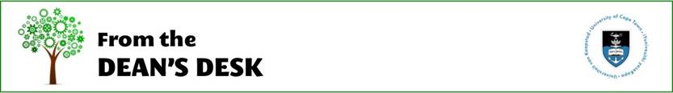
Dear Colleagues

I am writing to summarise the process for return to campus that many of you have been asking about.

Please remember that we can have a maximum of 1000 people (staff and students) back on campus in Phase 2, likely to be in early July. That is a very small number. EBE will account for a total of about 200 staff and students.

Return to campus protocol

- Lists of returning staff and students have been compiled and reviewed within departments. The final approval happens through the Faculty Health and Safety Committee and the Dean’s office.
- A formal letter of invitation will be sent from the University to these identified and approved staff and students. A travel permit will be issued through a central process. No-one will be able to access campus without these documents.
- There will be a central induction for all staff and students
- The Centre will provide all returning staff and students with the necessary PPE – 3 cloth masks and foot sanitisers for the buildings
- The Communication and Marketing Department will provide the COVID-19 signage for all buildings on campus.
- The necessary cleaning services will be put in place to ensure all cleaning protocol is adhered to.
- Department staff will be responsible for giving inductions that are specific to their laboratories.

Many many thanks to Professor Azeem Khan, Deputy Dean for Research and Postgraduate Studies, who has engaged with departments to collate the lists of postgraduate students and the staff.

To prepare for the return to campus, there is a massive amount of planning that needs to happen. As this is new territory for everyone, please bear with us. Our priority is to ensure the health and safety of our staff and students.

We will continue to update you as we get new information.

Kind regards
Alison
Professor Alison Lewis
Dean: Faculty of Engineering & the Built Environment

