

University of Cape Town
Department of Psychiatry and Mental Health
Invites you to attend an
Academic Lunch-time Lecture on 05 March @ 12h30
Valkenberg Education Centre Auditorium

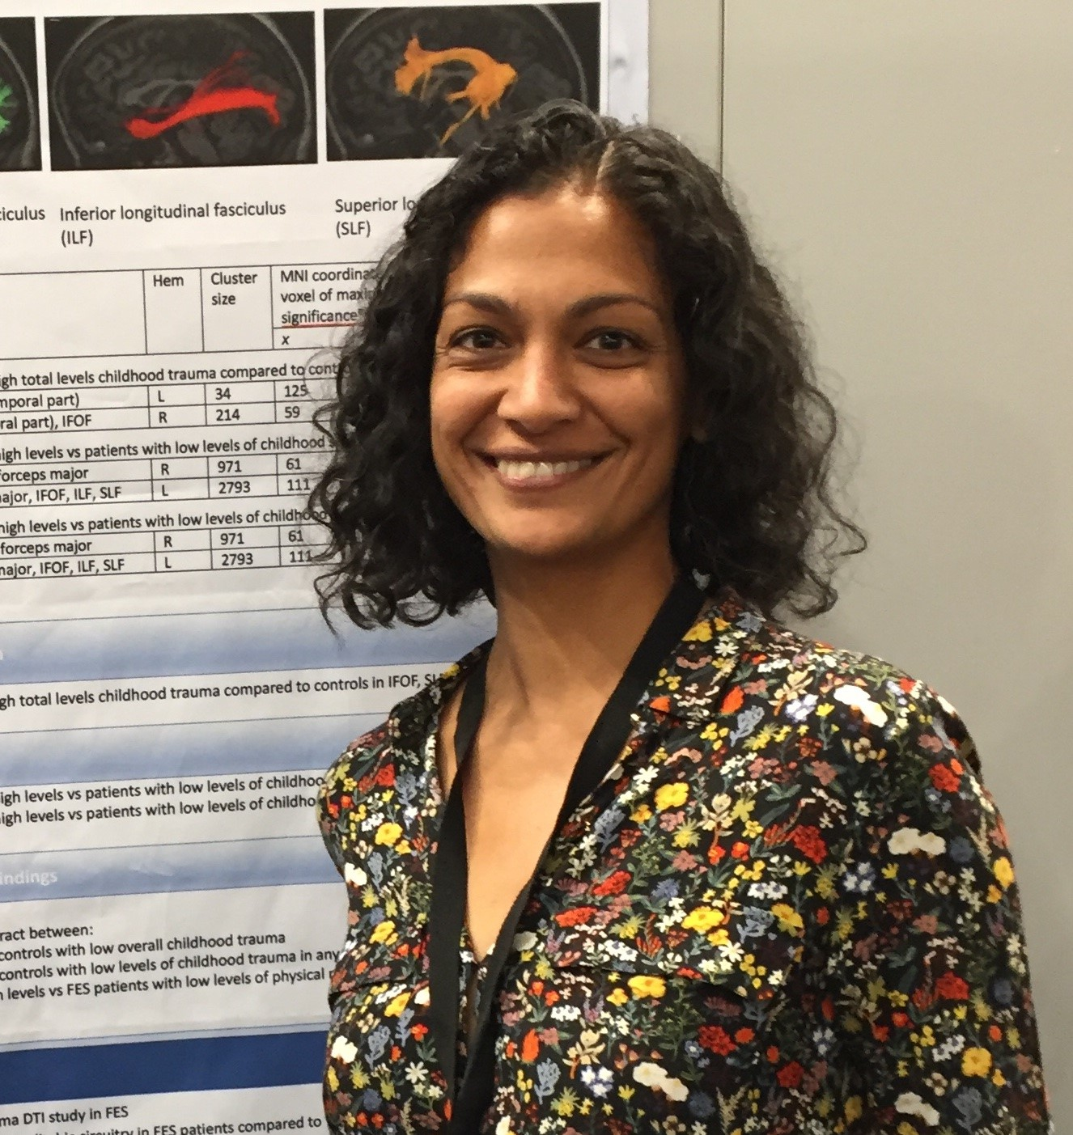

Speaker: Prof Laila Asmal

Prof. Laila Asmal is an Associate Professor at the Dept of Psychiatry, Stellenbosch University. She moved from UCT to Stellenbosch after graduating as a psychiatrist to take on a Schizophrenia Research Fellowship. She completed her MSc in Clinical Epidemiology and subsequently her PhD on brain imaging in a first episode schizophrenia cohort. She oversees the neuropsychiatry service at Tygerberg Hospital, has published widely in scientific journals and remains actively involved in schizophrenia research. Prof Asmal has a special interest in how we can ask the right research questions to address the needs of vulnerable people with mental illness.
Topic:
“Rigidity, resilience and the self: lessons I've learnt from Schizophrenia”.
Summary: What is the essential core of schizophrenia? The essential commonality that experienced clinicians can perceive but the DSM struggles to put into words? In this lecture, Prof. Asmal suggests that anomalous experiences of the self in a shared social world is a trait feature of schizophrenia. This self-world alienation begins in childhood or adolescence, is independent of psychosis but fundamentality related to the expression of psychotic experiences and insight. Linked to this, she presents the neuroscience associated with coping and rigidity in schizophrenia and in ourselves.

______________________________

